**CONTENTS**

1.Introduction 3

1.1 Background 3

1.2 Restatement of the Problem 3

1.3 Literature Review 4

2.Assumptions and Justifications 5

3. Dynamic Analysis 6

3.1 Symbols 6

3.2 Force Analysis 6

4. Locations of the Containers 8

4.1 Symbols 8

4.2 Coordinate Transformation 9

4.3 Ascertainment of the Positions 10

5. Research On the DroneGo Fleets 12

5.1 Constitution of the Fleets 12

5.1.1 Types of the Drones 13

5.2 Configuration of Cargo Bays 17

5.2.1 Analysis of the Delivering Drones 17

5.2.2 Analysis of the Reconnoitering Drones 18

6. Configurations of the Containers 20

6.1 Explanations 20

6.2 Loading Strategies 21

7. Tradeoffs and Solutions 21

7.1 The Setbacks We Meet 21

7.2 Related Solutions 22

8. Sensitivity Analysis 25

9. Conclusions 25

9.1 Strength 25

9.2Weakness 26

9.3Model Extension 26

10. Future Work 26

11. Memo 27

References 28

Appendix 28

1.Introduction

1.1 Background

The hurricane hit Puerto Rico in 2017 caused terribly huge damages to local people, both materially and spiritually. According to statistics, over 2900 people died of this disaster and numerous buildings and infrastructure were destroyed. The fierce wind and rain following the hurricane have put about 3.4 million people into a situation with no power. Goods necessary for living were in short, leaving people with hopelessness and frustration. The communication and transportation systems of Puerto Rico nearly broke down, which made it extremely hard to provide ground assistance and lifesaving supplies.

Due to the awful weather and road conditions, it is impossible for the ground rescuers to get into the disaster areas. Fortunately, drone, a new type of facilities, brings a brand-new resolution to this problem. With its stability and flexibility, it could get close to people stranded by the terrible weather. What’s more, the monitoring equipment on it will help to get the present transportation situation and collect related data, which is beneficial for designing plans of rescue. To make the best of drones and build an effective system for rescuing, we have a further exploration.

1.2 Restatement of the Problem

To deliver medical supplies for people suffering from hurricane and provide video reconnaissance of the disaster areas, we are required to build a transportable disaster response system called “DroneGo”. The Questions are as follows:

1. Identify packing configurations for the cargo containers.

2. Identify the best location or locations which will enable the drone fleet to transport the medical supplies and offer the video assistance of the road networks.

3. Identify the configurations, delivery routes and schedule of the drones which could meet Puerto Rico’s medical needs

4. Identify a flight plan to get the situations of the major highways and roads through the video equipment of the drones.

5. Write a memo to introduce our modeling results, conclusions, and recommendations to the CEO of HELP, In.

1.3 Literature Review

The strengths and potentials of drones in rescuing have aroused numerous researcher’s interest. Over the years, related researches have made great progress. The strengths of drones were elaborately summarized by Yang [1]. According to his induction, drones have the characteristics of lightness, sensitivity and stability. The endurance of battery and the low cost make them more competitive in transportation and rescuing. Besides, Yang’s paper shows that drones may make breakthrough in the cross-integration of advanced technologies such as stability control, remote monitoring, vital signs monitoring, injury identification and life support.

As for the transportation planning of disaster reaction, Zheng [2] came up with a bilevel programming dynamic model to *maximize the time satisfaction of the delivery time of relief materials in the upper 1evel and the fairness in the lower level*. Considering of the uncertainty of the demand of medicine and food, Tian [3] employed Triangular Fuzzy Numbers in Fuzzy Mathematics to deal with the fuzziness. Moreover, Zhu[4] used ant colony algorithm to analyze co-optimization problem. Yu-LinShih [5] took both *emergency roadway repair and relief distribution* into consideration and build a multi -objective programming model. Manoj Vanajakumari[6] divided the process of rescuing into three parts: before the disaster, during the disaster and after the disaster. Then the author used an integrated logistic model to analyze the optimal route and configuration.

However, the research of multi-task disaster reaction planning is still at an initial stage. What’s more, the combination of configuration and transportation planning is also under exploration. Though a lot of achievements have been made, we still have a long way to go. In this paper, we propose a brand-new method to balance the medical supply delivering and the video assistance tasks. Then we employ a loading software to determine the packing configuration in the containers and the cargo bays.

2.Assumptions and Justifications

For the simplicity and convenience, we make several assumptions. The rationality of each assumption is also given.

* **Ignore the influence of air flow such as wind on the force of drones.** The force provided by the battery is much greater than that from air flow.
* **Regard the earth as a standard globe.** In many situations, for the simplicity of calculation, the shape of the earth is always simplified as a globe.
* **Assume that all the drones move at a constant speed.** As we know, it is the speed-changing process that costs much energy. To fly as far as possible, it’s wiser to move in a constant speed. Moreover, the move of drones is controlled by related electronic systems, which make it easy to achieve the goal of flying in a fixed speed.
* **Ignore the breakdown of the drones**. The drones will get an overhaul after returning to the containers otherwise the HELP, Inc may suffer from great loss.
* **The containers can’t be removed easily.** Because the extremely terrible weather conditions and the large amount of supplies and drones contained in them will bring great trouble to the shift, it’s more realistic to leave the containers at their initial positions.
* **The containers are tough enough to be used for a long time.** Because most of containers are made of metal, alloy or high-strength composites.
* **The bottom of the containers and the cargo bays need to be filled firstly.** In this way, the probability of collision will be lower. Otherwise the items inside may get damaged when be transported.

3. Dynamic Analysis

3.1 Symbols

|  |  |
| --- | --- |
| **Symbols** | **Definition** |
| W | The energy of drones’ battery |
| P | The power of drones |
| t | The maximum flying time of drones |
| F | The traction force drones get |
| v | The velocity of drones |
| T | The lift drones get |
|  | The air density |
| S | The area of the rotor |
| KT | The coefficient of the lift |
| KQ | The coefficient of the torque |
| r | The radius of the rotor |
|  | The rotational velocity |
| s | The distance drones can cover |
|  | The angular velocity of the rotors |
| G | The gross gravity of the drones |

3.2 Force Analysis

In order to analyze the regulation between the velocity of the drones and the weight of the goods they carried, we established a dynamic model. The force analysis is as follows.

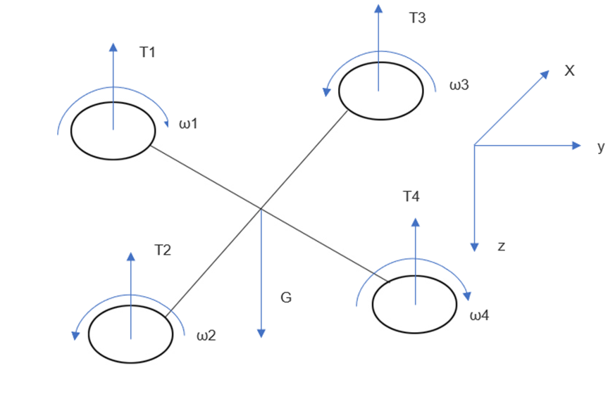

Figure 3.1 The Force Analysis of the Drones

According to Wang[7], micro air vehicles’ Reynolds number is about 20000, so the force implied on drones’ rotor is mainly viscous resistance. The viscous resistance varies directly as the velocity.

Moreover, we regard the energy of the battery as a fixed value.

 (1)

The power of the drone is the product of the traction force and the velocity.

 (2)

According to Aerodynamic Theory of rotor and blade of aircraft, when the blade rotates, lift T, resistance D, torque Q and the rolling moment L perpendicular to the plane of the wing will come into existence. All of them vary directly as the square of the rotational velocity Ω. Ignore the resistance D and the rolling moment L because their coefficient of them is nearly zero.

 (3)

 (4)

 (5)

Based on the researches above, we can draw the conclusion that the distance drones can cover obeys negative linear correlation with the total mass of the goods they carry.

Apart from the dynamic analysis, we also consider of the process that the drones lands on the ground. According to [8], the highest flying height of drones is about 400 feet and the average speed when they ascend or descend is around 5m/s. We estimate that the extra time cost during the procedure reaches at 50s. The electricity cost can’t be ignored. Based on the data about the decrease of the flying distance when carrying goods and the extra energy waste of the vertical motion, the parameter of the drones, especially the distance they can cover, should be re-considered.

All the data used in latter parts are adjusted according to this segment’s analysis.

4. Locations of the Containers

Question B require us to select the best position or positions for the containers to enable the DroneGo fleet to meet the demand of medical supplies in Puerto Rico and provide the high-resolution aerial video reconnaissance. For the simplicity, we calculate the distance between two positions from their coordinates. Because of the amount of the containers needed is unclear, for purpose of minimizing the cost, we try to use just one container firstly. However, according to the result, no matter what kind of drones we choose, the demand of medical supplies can’t be met at the same time. As a result, we decide to add more containers. Based on our analysis, two more containers are necessary. We finally decide their positions.

4.1 Symbols

|  |  |
| --- | --- |
| Symbols | Definition |
| xi | The distance between the first container to city i |
| yi | The distance between the second container to city i |
| zi | The distance between the third container to city i |
| R | The radius of the earth |
| i | The longitude angle of city i |
| i | The latitude angle of city i |
| TD | Total distance |
| **R** | The matrix of total packages requirement of two cities |
| **rij** | The total packages requirement of city i and city j |
| **D** | The matrix of the distance between two cities |
| **dij** | The distance between city i and city j |
| **R1** | The normalized **R** |
| **D1** | The normalized **D** |
| **K** | Subtract **D1** from **R1** |
| F | The objective function of the programming model |
| Xij | 0-1 variable |

4.2 Coordinate Transformation

According to our assumptions in Part 2, the earth can be regarded as a standard globe. So we can get the distance of two places through their longitude and latitude. First, transform the angle system to radian system. Here is the equation.

 (6)

Then calculate the distance through the following equation.  (7)

We compute the distances between these cities through C++.

4.3 Ascertainment of the Positions

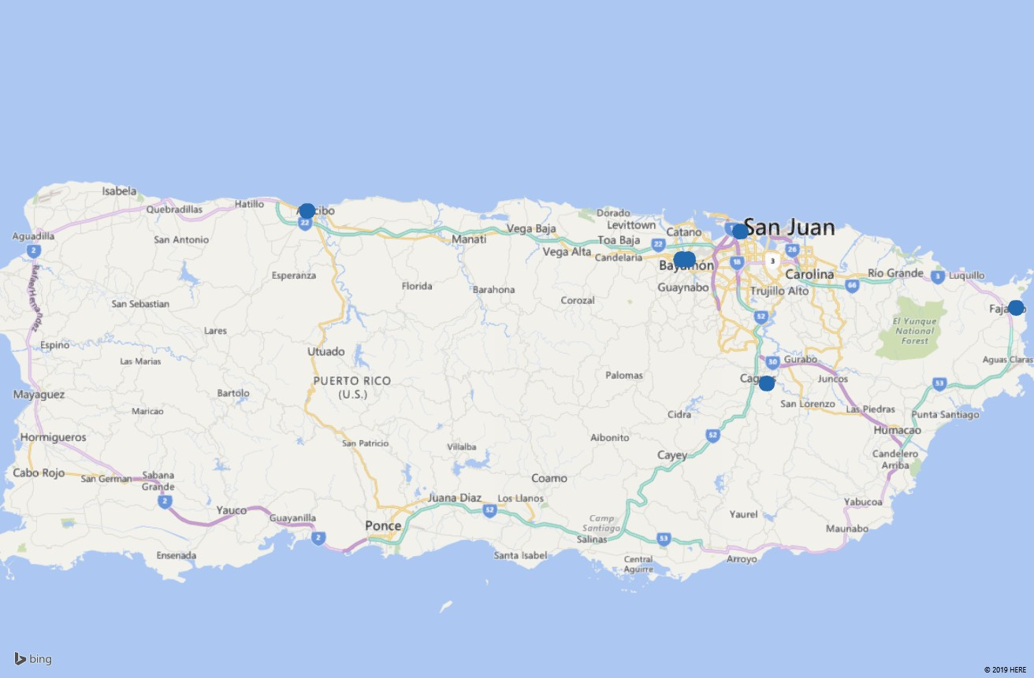By PowerMap, we determine the five cities through the coordinates provided. The relative positions are as follows.

**4.Fajado**

**1.**

**3.Caguas**

**2.Bayamón**

**5.Arecio**

Figure 4.1 Five Cities Corresponding to the Given Coordinates and Their Numbers

Firstly, we explore a situation with only one containers. As is known, the aim of after-disaster rescuing is providing adequate and timely support rather than reduce the cost as much as possible. Besides, **comparing to provide video assistance, medicine supply is much more urgent**. Life and health is the most important aspect in all conditions. To ensure the medical supply can reach at the disaster areas in time, we choose the total distance from the container to another five cities as the objective function and calcite its position through **Lingo**.

 (8)

, i=1,2,3,4,5

We get the coordinate of this place, **(18.39°N,66.15°W)**

However, no matter what kind of drones we choose, this container can’t meet Arecibo and Fajado’s demand of medicines in that case because the distance from this container to the two cities above is beyond the range of all of the drones.

Therefore, we consider placing more containers. In order to figure out the specific cities the containers support, we establish an **integrate linear programming model.** From Figure 4.1, if we take Arecibo into consideration, it’s impossible to take another city into account. **Thus, we put a container in Arecibo** which will meet the demand of the medicines and transportation reconnaissance of local people. We set two more containers for the four cities.(According to our algorithm, if only one more container is necessary, the outcoming of our model will express this information) This time we take both of the distances and the requirements of medicines into consideration and have a normalization on them.

**R= ** (9)

**D= **  (10)

Through the built-in function of Matlab, we get their corresponding normalized matrixes R1 and D1.

**K=R1-D1=**  (11)

Then, we define Xij as the variable to describe the connection state between i and j. If Xij=1, it shows that there is a location to aid I and j together or there is no location between them. We calculate the distance among these four places, we find that any pair of them could be touched by drone from the same location. So every variable could be 1 theoretically. Here is the objective function:

max F=*K*12×X12+*K*23×X12+*K14*×X14+*K24*×X24+*K34*×X34 (12)

s.t.

With Lingo，we work out that:

X12=X23=1，X13=X14=X24=X34=0 (13)

The result X14=X24=X34=0 shows that No.4 place, **Fajardo should be supported by one single container** and X12=X23=1 shows that San Juan, Bayamón and Caguas will accept the support from the third container and this is more practical and easier in real life.

To determine the location of the third container, we employed the **Lingo** algorithm again. The objective function is as follows.

 (14)

, i=1,2,3

We find that the coordinate of the third container nearly coincides with that of Bayamón, so **we choose Bayamón as the location of it**. Of course, according to the same principal as the ascertainment of the first container’s position, the second container should be placed at Fajado.

In all , **the three locations of the containers are at Arecibo, Fajado and Bayamón**.

5. Research On the DroneGo Fleets

5.1 Constitution of the Fleets

Question A ask us to give a recommendation on the constitution of the DroneGo Fleets. Comparing to other drones, several types of drones given have obvious strengths and specific functions. According to our judgement as well as the the fuzzy synthetic evaluation model based on the factor analysis model we establish, we finally choose four kinds of drones. Later, we determine the amount of the drones in each fleet on the basis of the medical and video reconnaissance requirements. As for the configuration of the cargo bays, we use a loading software, Cube-IQ, to simulate the layout of the medical supplies and drones. At the end of this part, we design the routes and arrangements of these drones to accomplish their mission of delivering medicines and collecting image information of the road networks.

5.1.1 Types of the Drones

To find out the most appropriate types of drones, firstly we compare them with each other straightly to find their special characteristics. We were attracted deeply by type H, the tethered one, for the first sight. This kind of drones will act as a signal collection to gather all the traffic information from the drones sent for video reconnaissance and each container will equipped with one. Besides, we employed fuzzy synthetic evaluation model to pick up three more types of drones to offer helps about medicine delivering and video reconnaissance. The influential factors’ weight depend on the result of the entropy method.

For ranking these seven types of drones except type H, we need to choose a criteria. We employed entropy method and find the contribution rate of the cargo capability, the velocity and the flying time of the drones. (Contrasting to the room of the container, the sizes of the drones are so small that we don’t take this factor into consideration. The configuration sketches of the containers also show that the room is large enough). The contribution rate we get will act as the weight of the fuzzy synthetic evaluation model.

Because we want to get the rate which this value occupies in total values with the absolute value, we shouldn’t make the standardization process. However, to avoid the bug when getting the log value, we should make the process of data translation as follows:

For the benefit type indicator, the data translation we define is:

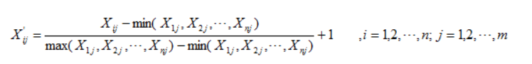

Instead of it, the cost type indicator’s data translation is:

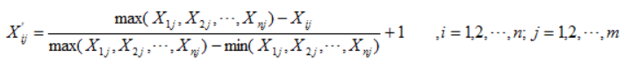

Obviously, the angular velocity and population are benefit type indicators while the distance is cost type indicator.

Next we calculate the rate of the indicator j in drone i:

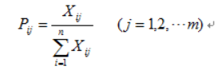

Then we calculate the entropy of the indicator j:

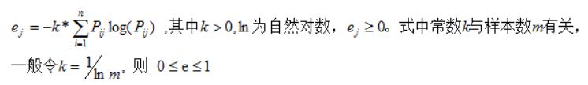

We calculate the diversity factor:

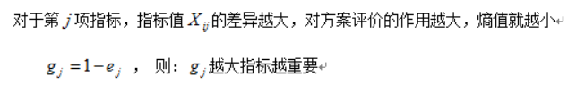

Finally we calculate the weight:

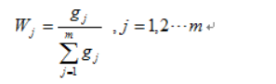

So wj is the weight for the fuzzy synthetic evaluation model.

According to our computation, the weight matrix is

**[0.27 0.23 0.50]**

We transfer the contribution rate as parameters to the fuzzy comprehensive evaluation.

We still take the cargo capability, the velocity and the flying time into consideration. First we determine the fuzzy positive value and the fuzzy negative value. The fuzzy positive or negative ideal value consists of the maximum or minimum value of each factors. Then we employed the tools used for computing the Euclidean distance to calculate the differences between each type of the drones to the fuzzy positive value. On the basis, we calculate each type of drones’ degree of membership of the fuzzy positive ideal situation. The greater the degree of membership is, the better the drones are.

**F** is the whole fuzzy set within real numbers. **M** is a part of **F.** If the membership function  of **M** can be descripted as follows:

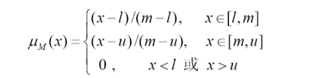

m[l, u]

Then M is a triangular fuzzy number.

M= (l, m, u) = (mL, m, mR)

According to this definition, we can descript the cargo capability, the velocity and the flying time of the drones as a triangular fuzzy number. If the index j of the type i is , according to the definition of the triangular fuzzy number, its triangular fuzzy number can be descripted as:

(外面的要黑体)=( , , )

We transform all the characteristics into triangular fuzzy number and get the fuzzy index matrix:

=()7×3

The contribution rate should be transformed into triangular fuzzy number. Obviously,  is a kind of income-based indicator. Its normalization formula is as follows:



The fuzzy matrix after normalizing is **(加粗)**

 （外面的****加粗）

We apply ordinary weighting method on the normalized fuzzy matrix **T**: 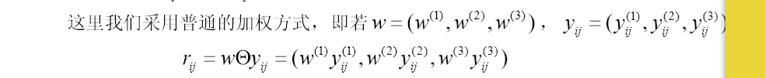

这里把yij用 替换掉，把rij用 替换掉

We can get the fuzzy decision matrix  加粗

 外面加粗

Next we give the definition of the fuzzy positive ideal situation M+ and the negative ideal situation M-.





Next we calculate the Euclidean distance di+ between the drones and the fuzzy positive ideal situation and the Euclidean distance di- between the drones and the fuzzy negative ideal situation.



If the type i drones obey the order of the fuzzy positive ideal situation, the degree of membership of this kind of drone is  :



We rank the seven types of drones according to the degree of membership in descending order and choose the top three types of drones to support the disaster areas.

|  |  |  |
| --- | --- | --- |
| **Rank** | **Types** | **The Degree of Membership** |
| 1 | 6 | 0.6651 |
| 2 | 3 | 0.6595 |
| 3 | 2 | 0.6272 |
| 4 | 7 | 0.5017 |
| 5 | 5 | 0.3951 |
| 6 | 1 | 0.3839 |
| 7 | 4 | 0.3396 |

5.2 Configuration of Cargo Bays

Based on these three kinds drones and there different performance, we divide the drones into two groups: the delivering drones and the traffic network monitoring drones. And we get the amounts of these drones for different using with the medical packages needed and the roads nearby the container.

Moreover, in specific situations, one drone can execute both of the two tasks if the delivering destination is on the road that needed to be monitored. In that case, a drone with enough flying distance and a video can manage it.

Apart from that, one type H drone is needed at each container’s position.

5.2.1 Analysis of the Delivering Drones

On the basis of each drone’s destination as well as the requirement of it and with the help of Cube-IQ, the configuration of each cargo bay can be determined easily.

Through the calculating of Cube-IQ, the drone we choose is large enough to carry the city’s daily requirement. So, one city’s requirement could be satisfied by just one drone. For the tenet of the medicine supply first, we determine to apply three drones at the same time to provide the medicines to three cities.

If the city is near the container, we choose one drone of type F to deliver, such as Arecio, Bayamón and Fajado because the type F has no reconnoitering ability, so it’s reasonable to apply it to one neaby destination.

Then, the unsure destinations are Caguas and San Juan. According to the (jingweidu) between them and Bayamon separately, we find that the (计算距离)distance between Caguas and Bayamon is (), which only type B could come to Caguas and return to Bayamon, so we could only apply type B drone for the Caguas medicine supply.

As to the San Juan, the capital of Puerto Rico, we want the drone could reconnoitering the roads during providing the medicines. Both type B and type C could perform these two missions at the same time. What’s more, according the results of fuzzy synthetic evaluation model above, the rank of type C is better than type B, So we apply the better performance one to do these tasks.

Finally, we could show the delivering plan of each drone with the table as follows:

|  |  |  |  |  |  |  |
| --- | --- | --- | --- | --- | --- | --- |
| Drone | Cargo Bay | From | To | MED1 | MED2 | MED3 |
| F | 1 | Arecibo | Arecibo | 1 | 0 | 0 |

|  |  |  |  |  |  |  |
| --- | --- | --- | --- | --- | --- | --- |
| Drone | Cargo Bay | From | To | MED1 | MED2 | MED3 |
| B | 1 | Bayamon | Caguas | 2 | 0 | 1 |
| C | 2 | Bayamon | San Juan | 1 | 1 | 0 |
| F | 2 | Bayamon | Bayamon | 2 | 1 | 2 |

|  |  |  |  |  |  |  |
| --- | --- | --- | --- | --- | --- | --- |
| Drone | Cargo Bay | From | To | MED1 | MED2 | MED3 |
| F | 1 | Fajardo | Fajardo | 1 | 0 | 1 |

5.2.2 Analysis of the Reconnoitering Drones

To get the most economic and appropriate amount of the drones, we select the type B drones to provide the video monitoring assistance from three types of moveable drones because it has the longest endurance mileage. We draw a circle in which all the possible range that the drones can see is included. When choosing the radius of the circle, we consider of the electricity cost of the vertical motion stage and leave a little energy to deal with the emergency. To conclusion, we use about 40 percent of the type B drones’ maximum flying distance as the radius because the drone should be back after finishing the task.

We circle the farthest range of view of the drones with the longest flying distance taking off from the container. The roads in the circle should be monitored per day.

As for drones which will fly to San Juan and Caguas, we choose two drones with reconnoitering ability so they could finish two tasks at the same time.

To cover most of the disaster areas’ road networks, the drones are expected to fly along the roads. So to other roads, we note them in the map so the drones could reconnoiter the roads when it flies just along the noted roads. And the amounts of these drones for each location could be directly determined from the maps as follows:

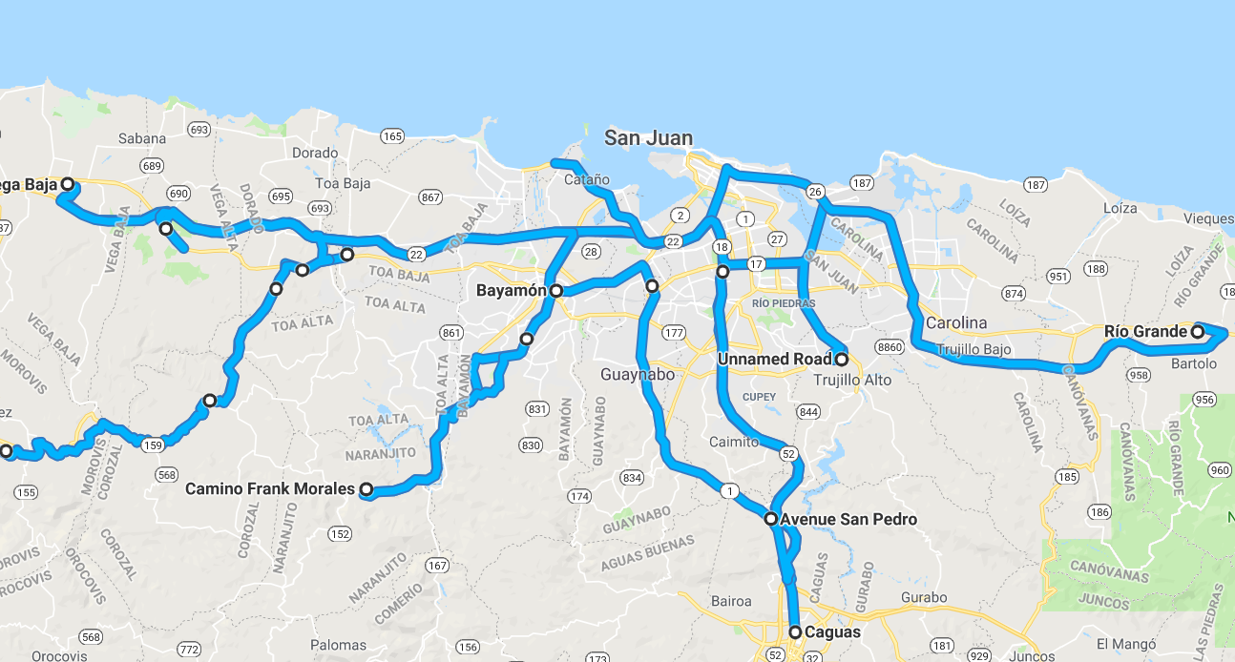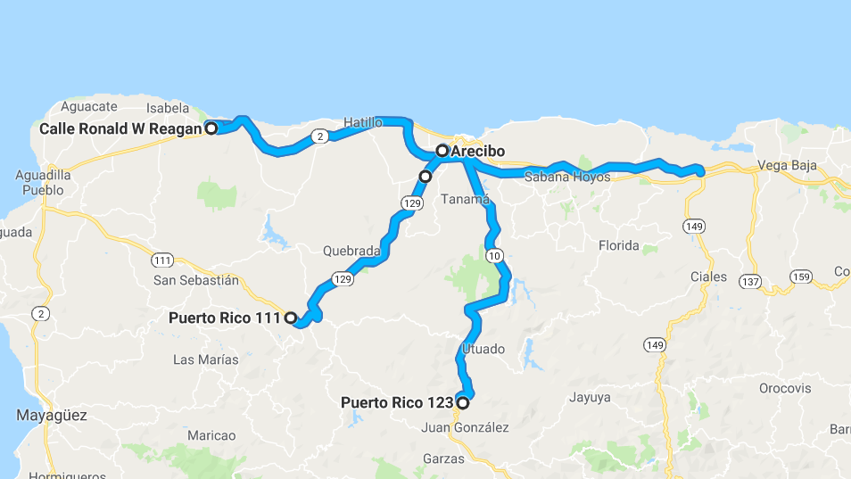

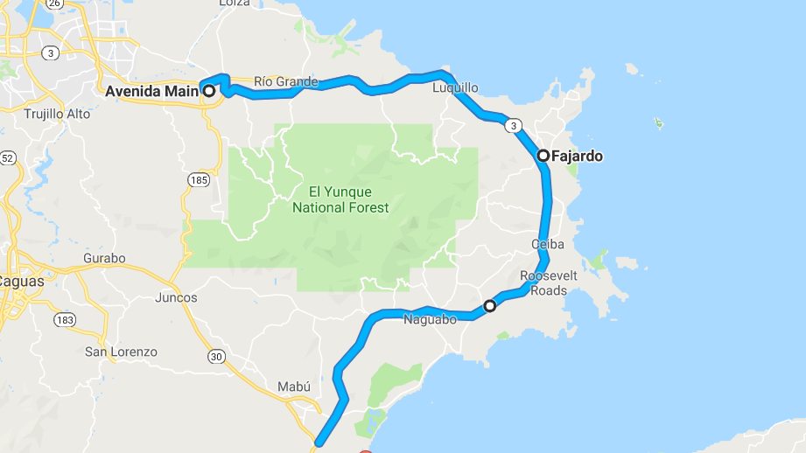

At last, type H drone is needed at each container’s position for communication.

We can also show the results with the table:

|  |  |  |
| --- | --- | --- |
| Location | Numbers of Drone B | Numbers of Drone H |
| Arecibo | 4 | 1 |
| Bayamon | 9 | 1 |
| Fajardo | 2 | 1 |

6. Configurations of the Containers

6.1 Explanations

Combining with the conclusions above, we can determine the configurations of the each countainer.

Though the aim of rescuing is to offer help to people in need timely and provide adequate necessities, it is also vital to reduce the cost, especially for the NGOs. So our modelling goal is to minimize the cost on the basis of finishing all the rescuing tasks. Because it’s hard to know the cost of each drone, so we assume that the price of each drone is the same. So our goal transforms into minimizing the amount of the drones.

1.For purpose of simplifying the rough three-dimensional objects loading problem, we search for related software on the Internet. We finally choose Cube-IQ to solve the problem because it provides a more intuitive loading plan and it’s much easier to cross the threshold comparing with other software.

2.To protect the drones and the medicines, we firstly fill the bottom of the container. Otherwise the collision may destroy the contents.

3.In order to provide enough supplies for the disaster areas and reduce the use of cushioning material, we decide to provide more goods than the realistic demand. However, for lowering the cost of purchasing medicines, we finally decide to provide goods to meet the demand of three months.

6.2 Loading Strategies

Through the analysis above, we can determine the types and the amounts of the containers’ contents. With the help of Cube-IQ, the configuration can be worked out easily.

7. Tradeoffs and Solutions

Though we can solve most of the problems we meet, there are still several troubles we can’t get over under such conditions. In order to overcome all the difficulties and set up a perfect aerial disaster relief response system, it’s necessary to make tradeoffs.

7.1 The Setbacks We Meet

Now we can fulfill the task of delivering medical supplies well. However, limited to the amount of the containers, we are not able to get all the information of the whole road system, which means the conditions of several parts of the roads are uncertain. On the basis of our model, the southwest part of Puerto Rico remains to be supported an the traffic system there needs to be monitored.

7.2 Related Solutions

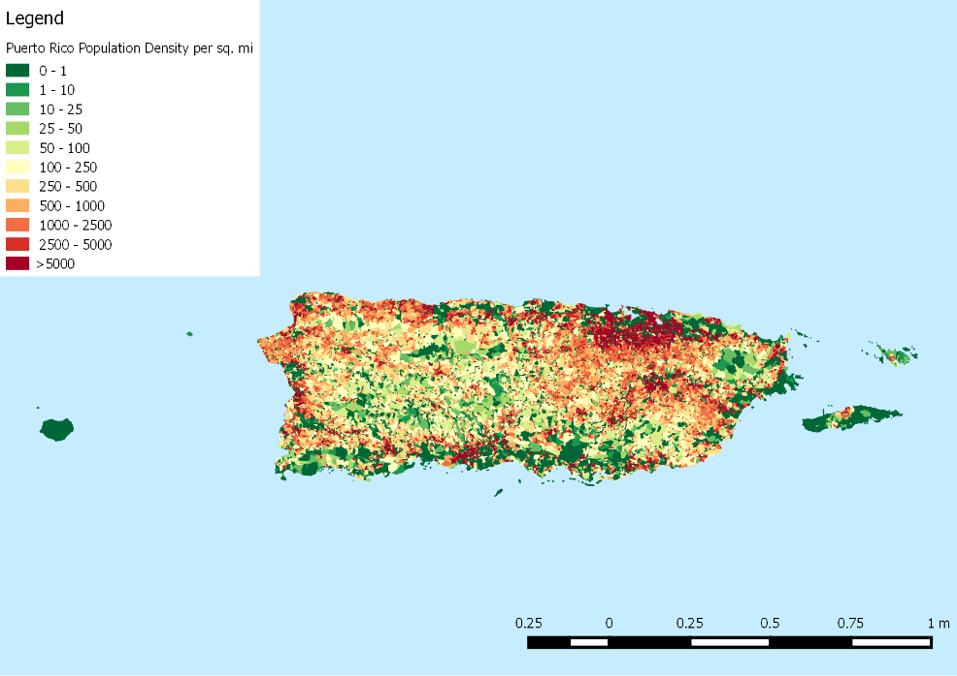We come up with a solution to cover more road networks and deliver medical supplies for people living in the southwest part of Puerto Rico. To accomplish this goal, one more container is needed. We refer to the population density of Puerto Rico and find that Ponce is the only major city in the southwest districts. So we decide to place the forth container in Ponce.

Figure 7.1 The Population Density Map in Puerto Rico

Next we employed a neural network model to estimate the possible demand of medical packages in Ponce. According to our judgement, the influential factors of the medicine demand include the population density as well as the impact the hurricane brings. The latter factor has something to do with the distance between the cities and the center of the hurricane as well as the strength of the hurricane. We use the angular velocity to represent the wind’s strength. On the basis of related data we collect, such as the route of the hurricane Maria, the total time for the hurricane to pass Puerto Rico, the initial velocity and angular velocity, as well as the assumptions we make, for example, the velocity and the angular velocity obey negative linear correlation with time, we get the parameters necessary to support our conception and successfully estimate the Ponce’s requirements of medical supplies by employing the neural network model.

We construct a BP network to predict Ponce’s specific demand of each kind of medical package. The BP network has an input layer consisting of three kind of data mentioned above, an output layer consisting of the demand of the medical supplies and a hidden layer. If enough nodes are available, we can approximate a nonlinear function with any accuracy. So we can forecast the demand through such a three-layer multi-input and single-output BP network with a hidden layer. We use this formula to determine the neuron amount of the hidden layer.



 is the amount of the input layer neurons. In this model the value is three.

 is the amount of the output layer neurons. In this model the value is one.

 is a real number from one to ten.

According to this equation, the number of the hidden layer neurons is from three to twelve. We choose eight as the value.

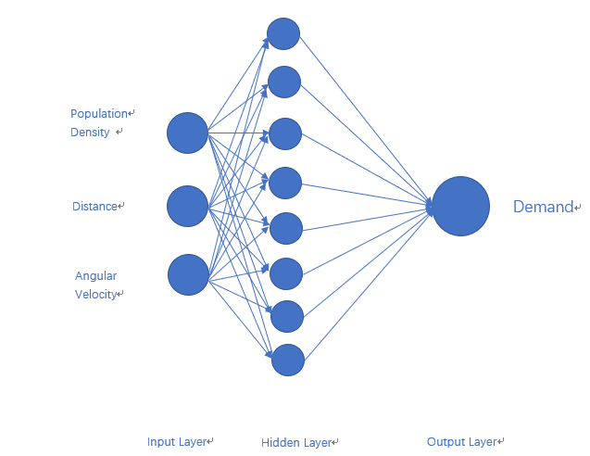Figure 7.2 The BP Network

The BP neutral network usually choose Sigmoid differentiable function and linear function as the inspirit function of the network. We choose the S-type tangent function tansig as the inspirit function of the hidden layer and the S-type logarithmic function logsig as the inspirit function of the output layer.

We apply Matlab to program and use the traingdx function as the network training function and the mse function as the network performance function. We set the iteration times to 50,000, the expected error to 10-8 and the learning rate to 0.01. The forecast result is as follows.

|  |  |  |
| --- | --- | --- |
| **Types of Medical Packages** | **Epochs** | **Daily Demand** |
| MED1 | 16 | 0.3 |
| MED2 | 23 | 0.2 |
| MED3 | 301 | 0.5 |

Figure 7.3 The Calculation Result of the Neural Network Model

According to the demand of the medical packages and the road networks around Ponce, we can easily determine the daily deliver plan and the configuration of the container or the cargo bays. For lack of space, we give the flying routes only.

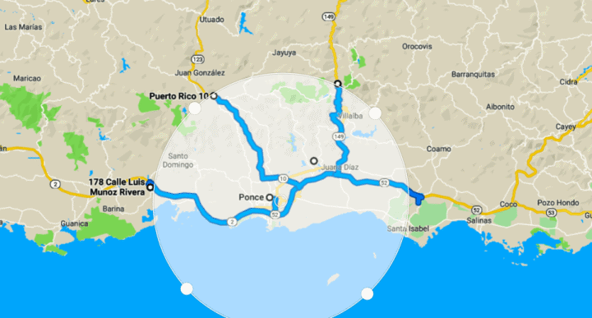

Figure 7.4 The Flying Routes of the Drones

8. Sensitivity Analysis

The weights in fuzzy synthetic evaluation model have a direct impact on the types of the drones we choose. To avoid the contingency, we get another set of weights through factor analysis model. We can get the contribution of each divisor so we calculate the rate of contribution as the weights. In this model, we set all these three properties as the principal divisor to get the best objectivity. According to our calculation, the new weight matrix is

**[0.27 0.36 0.37]**

Then we test the result using these weights in fuzzy synthetic evaluation model.

|  |  |  |  |  |  |  |  |
| --- | --- | --- | --- | --- | --- | --- | --- |
| **Weights\Ranks** | 1 | 2 | 3 | 4 | 5 | 6 | 7 |
| **(0.27,0.23,0.50)** | C | B | F | A | G | E | D |
| **(0.27,0.36,0.37)** | F | C | B | G | E | A | D |

(Weights\Ranks 该格把对角线连起来吧)

We can find that the change of weights dose affect the result but the top three drones are still B、C and F. What’s more, the drone C are still better than drone B when delivering the medicine if the distance is not too long. So, the change of this rate will not affect our plan for delivering, which shows that these drones’ performances are excellent enough to withstand the change of weights and our plan for choosing these three drones are reasonable. This shows that our model has good stability and strong adaptability.

9. Conclusions

9.1 Strength

* The fuzzy comprehensive evaluation model provides a rather objective method of ranking the drones according to their characteristics.
* The factor analysis model determine the influential weight coefficient and reduce the subjectivity of expert evaluation.
* The use of simulation software simplify the hard three-dimensional loading problems and saves a lot of time.
* The ascertainment of the flying radius takes both the extra electricity cost of the vertical motion and the influence of the medical supplies’ weight into consideration, which makes the analysis more realistic.
* Sensitivity analysis shows that our model is robust and reliable

9.2Weakness

* The total amount of the medicines provided is estimated by us because of the information limitation.
* In part 7, we only analyze Ponce to represent the southwest part of Puerto Rico. Though it’s easier for solve problems, the universality can’t be shown.

9.3Model Extension

Our model can be extended to many industries, such as the city planning industry, logistic management industry, capital evaluation industry and so on.

Take the logistic management industry as an example. This industry will face a lot of questions about choosing locations of the logistics center or designing logistic networks. Take related factors such as the cost or the distance into consideration and using the programming model to determine the location of them.

10. Future Work

Due to the limited time and the incomplete data, we are not able to give a thorough plan for building the aerial disaster relief response system. We will continue our study and try to improve our research in these aspects in the future:

1. Collect more detailed statistics of the disasters happened in Puerto Rico, such as the lasting time of the storms, the destroyed degree of different cities and the demand of lifesaving goods of different areas.

2.Research the regulation of the hurricanes hit Puerto Rico and come up with a system to predict such disasters.

3.Provide related suggestions on local government.

11. Memo

References

[1] Yang Yang, Luo Ting, Tang Gewei, Zhang Jiaxiong, & Wang Hefei. (2018). Research on the application of multi-rotor uav in medical rescue. Medical Equipment, 39(6).

[2] Zheng Bin, Ma Zujun, & Zhou Yufeng. (2017). A bilevel programming model for dynamic site-intermodal transport of emergency logistics after earthquake. Chinese Journal of Hospital Infection, 26(10), 326-337.

[3] Tian Jun, Ma Wenzheng, Wang Yingluo, & Wang Kanliang. (2011). Particle swarm optimization (pso) for dynamic dispatch of emergency supplies. Systems Engineering Theory and Practice, 31(5), 898-906.

[4] Zhu Li , Ding Jialan , & Ma Zheng . (2018). Collaborative optimization of heterogeneous transport under emergency conditions. Journal of Management.

[5] Yan, S. , & Shih, Y. L. . (2009). Optimal scheduling of emergency roadway repair and subsequent relief distribution. Computers and Operations Research, 36(6), 2049-2065.

[6] Vanajakumari, M. , Kumar, S. , & Gupta, S. . (2016). An integrated logistic model for predictable disasters. Production and Operations Management, 25(5), 791-811.

[7] Wang Dapeng. (2017). Analysis of Flight Dynamics Characteristics of Four-Rotor Aircraft. (Doctoral dissertation).

[8]https://www.faa.gov/news/press_releases/news_story.cfm?newsId=18295&cid=TW299

Appendix